# kwaSouth Africa (plus the small connection into Lesotho)

## Summary

### Nodes

|  |  |
| --- | --- |
| railway | count |
| null | 45451 |
| switch | 11280 |
| level_crossing | 6318 |
| buffer_stop | 4287 |
| station | 1585 |
| stop | 932 |
| halt | 691 |
| crossing | 472 |
| platform | 434 |
| abandoned | 357 |
| railway_crossing | 99 |
| turntable | 8 |
| signal | 6 |
| blockpost | 4 |
| service_station | 4 |
| tram_stop | 3 |
| subway_entrance | 2 |
| milestone | 1 |
| spur_junction | 1 |
| pantograph_scanner | 1 |
| yard | 1 |
| razed | 1 |
| junction | 1 |
| tram_level_crossing | 1 |
|  |  |
|  |  |

Railway tag value and count where name tag value is not null.

|  |  |
| --- | --- |
| railway | count |
| station | 1565 |
| stop | 931 |
| halt | 677 |
| abandoned | 346 |
| null | 250 |
| platform | 105 |
| level_crossing | 13 |
| service_station | 4 |
| blockpost | 4 |
| tram_stop | 3 |
| subway_entrance | 2 |
| junction | 1 |
| yard | 1 |
| spur_junction | 1 |
|  |  |
|  |  |

### Edges

#### All edges – status

|  |  |
| --- | --- |
| open | 56295 |
| disused | 3962 |
| abandoned | 3888 |
| razed | 333 |
| historical_planned | 6 |
| construction | 5 |

#### All edges – type

|  |  |  |
| --- | --- | --- |
| conventional | 55130 | |
| other | 9036 | |
| preserved | 176 | |
| light_rail | 71 | |
| miniature | 33 | |
| monorail | 23 | |
| tram | 16 | |
| funicular | 4 |

#### Named edges

#### Bridge/viaduct

|  |  |
| --- | --- |
| Null | 60379 |
| bridge | 3202 |
| platform | 782 |
| viaduct | 106 |
| turntable | 13 |
| station | 4 |
| traverser | 3 |

## Information

<https://www.bbc.co.uk/news/world-africa-60202570>

<https://www.sinfin.net/railways/world/safrica.html>

<https://en.wikipedia.org/wiki/Rail_transport_in_South_Africa>

* Majority of network is 1067mm gauge
* Some 314km of 610mm gauge said to still be in operation (<https://www.sinfin.net/railways/world/safrica.html>)
* **Gautrain** – express commuter rail is 1435mm gauge (<https://en.wikipedia.org/wiki/Gautrain>) - between Pretoria and Johannesburg, with a link to Johannesburg International Airport
* **Transnet** - national railway network and freight operator on the network 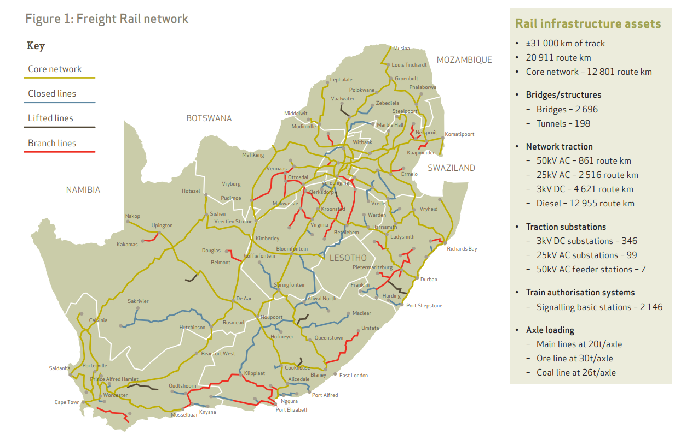
* 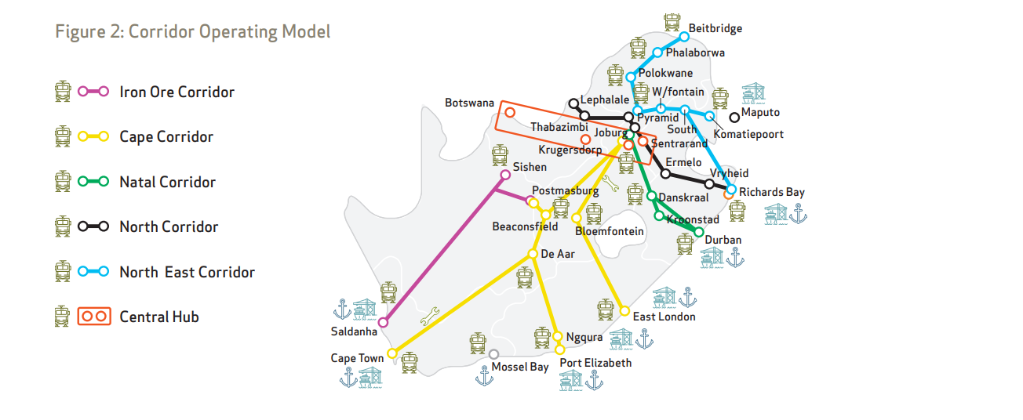

Figure https://www.transnetfreightrail-tfr.net/Rail%20Network/Pages/Rail-Netwok-Map.aspx

* + **Cape Corridor** (<https://www.transnetfreightrail-tfr.net/BU/ABL/Pages/Overview.aspx>) “The Cape Corridor stretches from Warrenton in the North-East to Cape Town in the South. Railway lines from the key mining area surrounding Hotazel in the Northern Cape connect to the ports of Gqeberha and Ngqura in the South-East, providing the primary export channel for South Africa’s manganese exports. Rail corridor links between mines and the Central Corridor also enable the transportation of manganese and iron ore for domestic markets.” “The Cape Corridor includes various Branch lines such as Bellville-Bitterfontein, De Aar-Upington and sections of the lines from Bloemfontein to East London and Gqeberha. The Cape corridor also includes the rail line linking the Port of Cape Town to the Reef and which also connects with the Ore line and Namibia.”
  + **Container Corridor** (<https://www.transnetfreightrail-tfr.net/BU/CAB/Pages/Overview.aspx> ) “The Container Corridor links the Port of Durban with the Gauteng economic hub through an extensive rail network of 688km. This connectivity enables direct railing of strategic commodities from the Port of Durban to the inland terminals of City Deep, Kascon, Pretcon, Kaalfontein, and several private sidings in the Gauteng area and beyond. The Container Corridor connects and interfaces with the North Corridor, Cape Corridor, and Central Corridor. The Container Corridor boundaries are described as below:
    - Port of Durban to Port Shepstone on the Kwazulu Natal South Coast up to Stanger on the North Coast;
    - Pietermaritzburg to Newcastle;
    - Northern Free State made up of Kroonstad and Bethlehem;
    - Johannesburg in the Gauteng province.
  + **North Corridor** (<https://www.transnetfreightrail-tfr.net/BU/Coal/Pages/Overview.aspx>) “The most prominent line section is the heavy-haul export line between Ermelo-South and Richards Bay. It serves the Mpumalanga coalfields via a feeder network known as the Coal Backbone. The system also serves the Waterberg coalfields by means of the Waterberg line and the Gauteng Freight Ring. The dominant direction is from Lephalale towards Pyramid South with chrome, domestic coal, export coal, cement and ferrochrome being the top commodities. Chrome and ferrochrome originates between Phokeng and Pendoring and is mainly transported to Richards Bay for export. Domestic coal originates form Mpumalanga and Lephalale and is transported to various destinations around the country.”
  + **Iron Ore Line** (<https://www.transnetfreightrail-tfr.net/BU/IOM/Pages/Overview.aspx>) “The Ir​on Ore line is one of the two main Heavy Haul Lines in South Africa, together with the Coal Line. The Iron ore corridor stretches 861 km from Sishen in the Northern Cape to Saldanha Bay on the West coast.” See: <https://en.wikipedia.org/wiki/Sishen%E2%80%93Saldanha_railway_line> (freight only). The Sishen – Saldanha line is electrified. Operating speed 80 km/h. 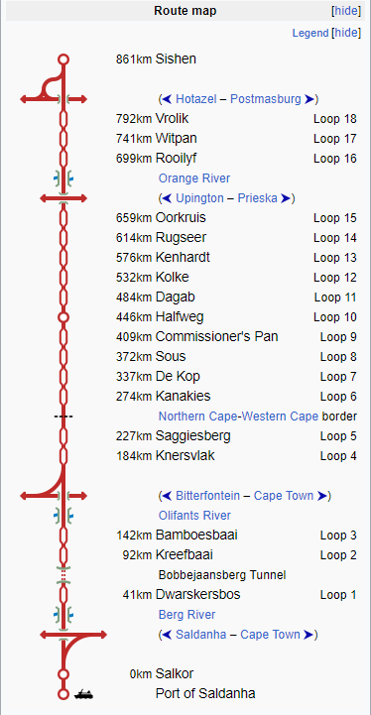
  + **North-East Corridor** (<https://www.transnetfreightrail-tfr.net/BU/MMC/Pages/Overview.aspx>) “The North-East corridor (NEC) consists of two (2) clusters namely the Beitbridge, Polokwane, Phalaborwa cluster which supports Limpopo, and the Witbank to Komatipoort cluster which supports Mpumalanga. The corridor stretches from Limpopo River at Beitbridge in the Limpopo province through Komatipoort down to Richards Bay on the East coast and;

from Pyramid/Witbank (Rayton) to Komatipoort. This corridor strategically links the South African freight business with that of other SADC countries mainly through Swaziland, Zimbabwe, Maputo, Zambia, and the DRC. The corridor has three prominent linear flows (Pit to Port) and are defined as follows:

* + - Phalaborwa to Maputo and Richards Bay, mainly transporting Magnetite and Rock Phosphate.
    - Witbank to Maputo, mainly transporting Chrome and Coal.
    - Intermodal (Reefers) originating from Tzaneen, Musina and Bela Bela destined for Durban.
  + **Central Corridor** (<https://www.transnetfreightrail-tfr.net/BU/SAC/Pages/Overview.aspx>) “The Central Corridor consists of the Krugersdorp-to-Mafikeng line, including Lichtenburg-to-Coligny mainline and surrounding branchlines as well as the Sentra and Complex in the center of the Gauteng province … comprises the key junction and interfaces railway areas of Pretoria, Isando and Sentrarand – known as the Central Hub – with PRASA, the passenger rail service. This Central Hub is the pivot or junction for rail traffic moving between the other corridors”
* **PRASA (Metrorail)** – passenger and commuter rail services (state owned under DoT). Some routes run on track that is owned and operated by PRASA, while others run on track operated by Transnet (also used for long-distance and freight trains).
  + Metrorail Gauteng (<https://en.wikipedia.org/wiki/Metrorail_Gauteng> (1067mm). Electrified
  + Metrorail KwaZulu-Natal (<https://en.wikipedia.org/wiki/Metrorail_KwaZulu-Natal>) (1067mm). Electrified. Durban area. 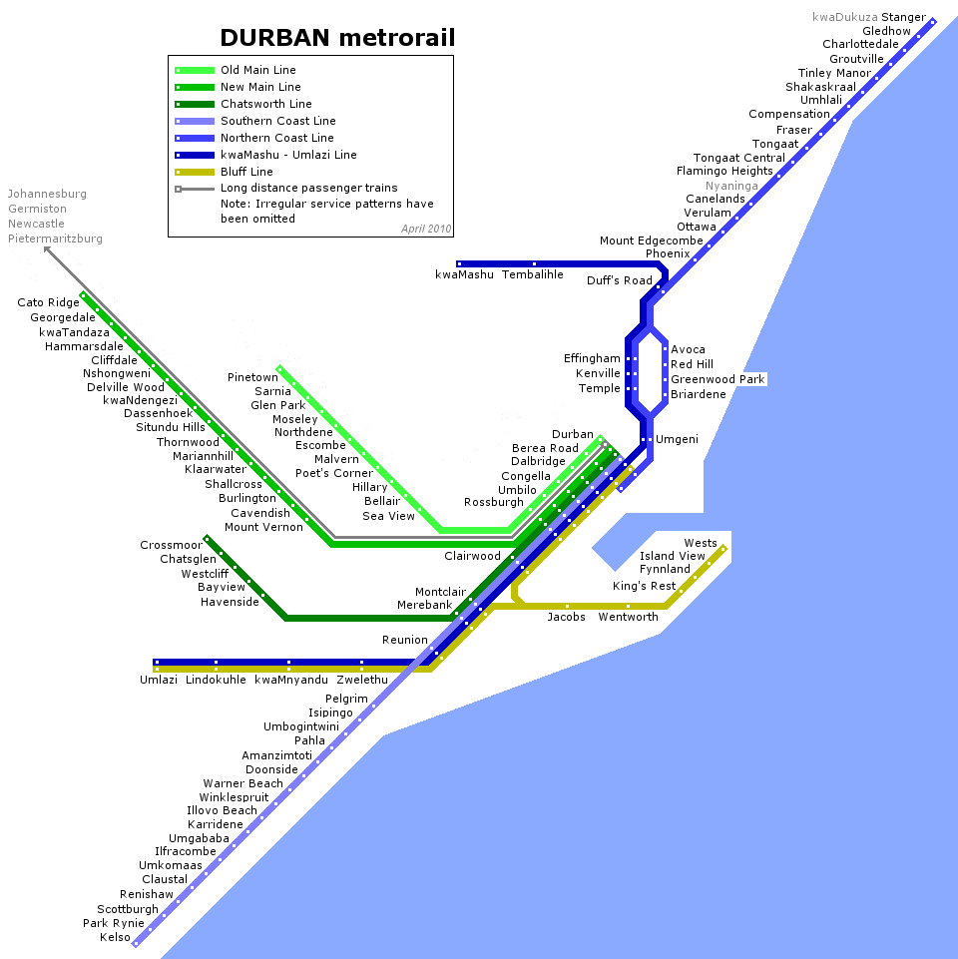
  + Metrorail Eastern Cape (<https://en.wikipedia.org/wiki/Metrorail_Eastern_Cape>) (1067mm). Diesel. Note that currently services appear not to be running due to theft and vandalism. See: 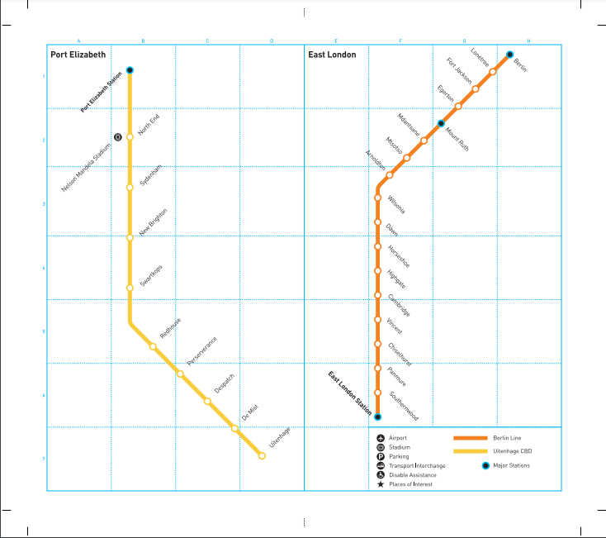
  + Metrorail Western Cape (<https://en.wikipedia.org/wiki/Metrorail_Western_Cape>) (1067mm). Electrified. <https://cttrains.co.za>.
    - Parts of the Central Line (blue in plan below) is out of use due to vandalism and theft. Branches down to Kapteinsklip and Chris Hani are affected. See: https://www.groundup.org.za/article/state-mitchells-plain-train-stations/.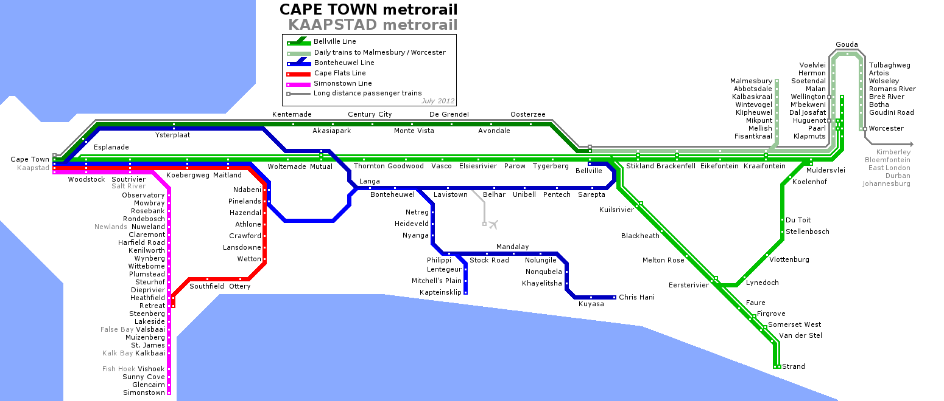
  + Long distance passenger services run by PRASA under name Shosholoza Meyl – see <http://www.shosholozameyl.co.za>. Timetable: <http://www.shosholozameyl.co.za/train-routes.aspx>. Only two routes: Johannesburg – Queenstown (Komani) and Johannesburg (Via Polokwane) – Musina. 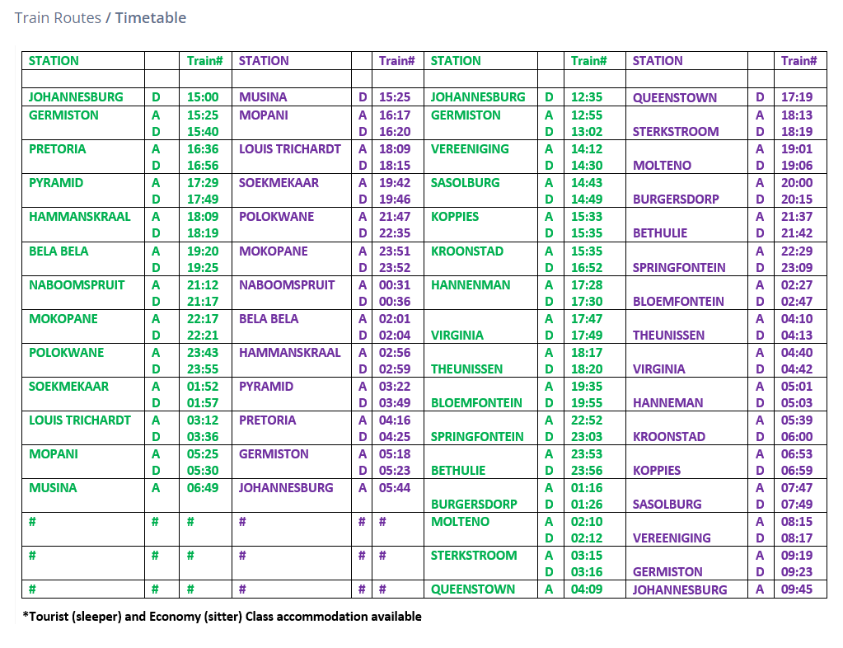
* **Private Railways**
  + Ceres Railway Company private freight line from Wolseley (connection with Transnet) via Ceres to Prince Alfred Hamlet, about 26 km. Also operates tourist passenger services (<https://www.ceresrail.co.za>)
  + Eskom private freight line under construction from Ermelo, Mpumalanga (connection with Transnet) to Majuba Power Station, about 68 km.
  + Kumba Iron Ore operates a 1067mm gauge rail network at its Sishen mine in Northern Cape Province, loading trains for onward haulage by Transnet

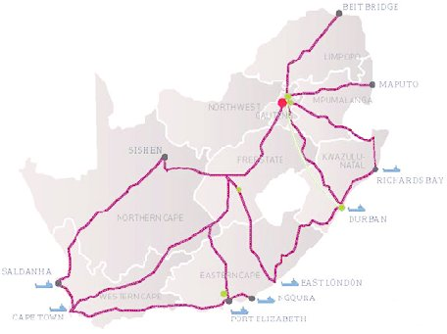

Figure The Freight Railway Network in South Africa <https://www.researchgate.net/publication/282525828_Vibration_Monitoring_of_a_Large_Scale_Heavy_Haul_Railway_Viaduct/figures?lo=1> [2015 paper]